AP Environmental Science
(A.P.E.S.)

Neshaminy High School Instructor: Brian Suter

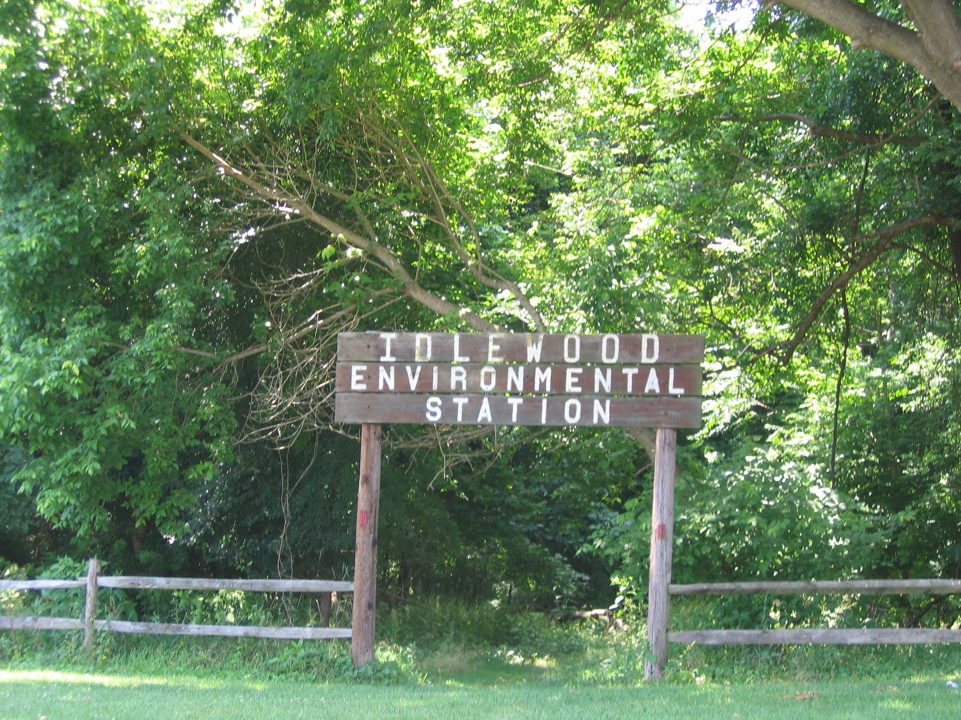

Text: “Living in the Environment, 18th Edition” (Miller, 2014)

APES is a rigorous, challenging course, designed to deliver the content and experience of a college-level freshman Environmental Science class. Because of the vast amount of content to be covered, we move through the material quite quickly, and it is essential to keep up as we go. The course culminates with the AP Environmental Science National Exam, given in May.

There are two major components to the course: Content and Field Studies.
We alternate between single and double periods throughout the week. Due to the variation in duration of our labs, sometimes we will confine our lab work to the double periods while other times, we may utilize multiple days.

Grades are generated primarily from tests and lab reports. In addition, there may be in-class activities and homework that will be graded as well. Points are accumulated, and grades are calculated as points earned as a percentage of the total points available.

Our course syllabus will be available on my district webpage.

You can reach me at my email ( bsuter@neshaminy.org) with questions regarding material, lab data, etc. after school hours.

Our final exam/project will include participation in the Bucks County Envirothon as well as completing a culminating STEM Project. The group who competes at states will use the preparation to compete at this level in lieu of this project.

